آرین حاجی زاده 99411281

Given non-linear function

% input signal :

clear;

flag = 0;

u(1) = 0;

for k = 2:401

u(k) = 0.5*sin(pi*(k-1)/11) + 0.4*cos(pi*(k-1)/6.5)+0.2*sin(pi*(k-1)/45);

end

figure();

plot(0:k-1,u);

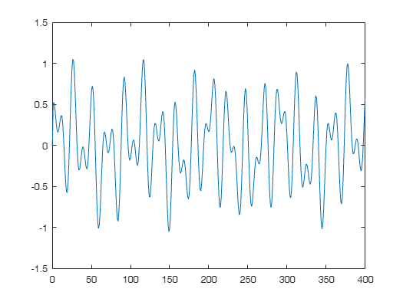

alpha = 1.2;

beta = [1.1 1.5];

% y_nlf -> y non-linear function

y_nlf(1,:) = [0,0];

y_nlf(2,:) = alpha*u(2)*ones(1,2);

X(1,:) = [u(1) y_nlf(1,1) 0];

X(2,:) = [u(2) y_nlf(2,1) y_nlf(1,1)];

for k = 3:400

y_nlf(k,:) = alpha*((y_nlf(k-1)*y_nlf(k-2)*(y_nlf(k-2) + beta))/(1+(y_nlf(k-2)^2).*(y_nlf(k-1)^2)) + u(k));

X(k,:) = [u(k), y_nlf(k-1,1),y_nlf(k-2)];

end

for i = 1:size(X,2)

X(:,i) = X(:,i)./max(X(:,i));

end

tmp = 1;

tmp2 = 1;

% Cross varidation (train: 70%, test: 30%)

cv = cvpartition(size(X,1),'HoldOut',0.2);

idx = cv.test;

% Separate to training and test data

x_train = X(~idx,:);

y_train = y_nlf(~idx,:);

x_test = X(idx,:);

y_test = y_nlf(idx,:)./max(y_nlf(idx,:));

%normalizing

d_k = y_train(:,1)/max(y_train(:,1));

figure;

plot(0:399,y_nlf(:,1));

title("output data : y(k)")

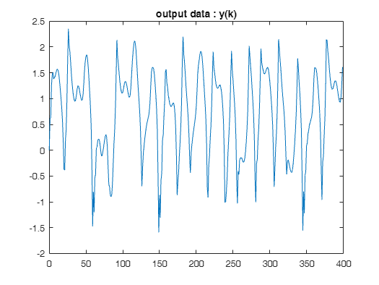

k = 40;

% [index,centers] = kmeans(x_train,k);

centers = myKmeans(x_train,k);

max_d = 0;

for q = 1:k

for e = 1:k

if(norm(centers(e)-centers(q)) > max_d)

max_d = norm(centers(e)-centers(q));

end

end

end

% getting sigmas according to handouts and the book with K-means and RLS

sigma = max_d*max(max(d_k))/sqrt(2*k) ;

% this function is defined at the end of the file

[output, Phi] = rbf_HL(x_train, centers, sigma);

[output_test, Phi_test] = rbf_HL(x_test,centers,sigma);

% adding bias to the weights

Phi = [Phi , ones(size(x_train,1),1)];

Phi_test = [Phi_test , ones(size(x_test,1),1)];

lambda = 0.08;

%this should be a small number

P{1} = lambda * eye(k+1);

r(:,1) = Phi(1,:)' * d_k(1);

% same as MLP

tmp_validation = 1;

loss_validation = 1;% initialization

for epochs = 1:100

if epochs == 1

w(:,1) = zeros(k+1,1);

g(:,1) = zeros(k+1,1);

else

w(:,1) = w(:,size(x_train,1));

end

for n = 2:size(x_train,1)

P{n} = P{n-1} - (P{n-1}*Phi(n,:)'*Phi(n,:)*P{n-1})/(1+Phi(n,:)*P{n-1}*Phi(n,:)');

g(:,n)= P{n} * Phi(n,:)';

%prior estimation error

pre(n) = d_k(n) - Phi(n,:)*w(:,n-1);

w(:,n) = w(:,n-1) + g(:,n) * pre(n);

end

y_pred = Phi * w(:,end);

mse(epochs) = mean((d_k - y_pred).^2);

if mod(epochs, 1) == 0

fprintf('Epoch %d, Loss: %f\n', epochs, mse(epochs));

y_test_pred = Phi_test * w(:,end);

loss_validation(tmp_validation) = mean((y_test(:,1) - y_test_pred).^2);

loss_compare(tmp_validation) = mse(epochs);

fprintf('Epoch %d, Loss validation: %f\n\n', epochs, loss_validation(tmp_validation));

tmp_validation = tmp_validation + 1;

end

if(tmp_validation > 2)

if(abs(loss_validation(tmp_validation -1) - loss_validation(tmp_validation -2)) < 0.0001 && ...

abs(loss_validation(tmp_validation -1) - loss_compare(tmp_validation -1)) < 0.01)

tmp_epoch = epochs;

break;

end

end

tmp_epoch = epochs;

end

Epoch 1, Loss: 0.018819

Epoch 1, Loss validation: 0.024600

Epoch 2, Loss: 0.009494

Epoch 2, Loss validation: 0.013958

Epoch 3, Loss: 0.006606

Epoch 3, Loss validation: 0.010596

Epoch 4, Loss: 0.005240

Epoch 4, Loss validation: 0.008859

Epoch 5, Loss: 0.004461

Epoch 5, Loss validation: 0.007786

Epoch 6, Loss: 0.003971

Epoch 6, Loss validation: 0.007067

Epoch 7, Loss: 0.003646

Epoch 7, Loss validation: 0.006558

Epoch 8, Loss: 0.003421

Epoch 8, Loss validation: 0.006183

Epoch 9, Loss: 0.003261

Epoch 9, Loss validation: 0.005898

Epoch 10, Loss: 0.003142

Epoch 10, Loss validation: 0.005674

Epoch 11, Loss: 0.003052

Epoch 11, Loss validation: 0.005493

Epoch 12, Loss: 0.002982

Epoch 12, Loss validation: 0.005343

Epoch 13, Loss: 0.002924

Epoch 13, Loss validation: 0.005216

Epoch 14, Loss: 0.002877

Epoch 14, Loss validation: 0.005107

Epoch 15, Loss: 0.002836

Epoch 15, Loss validation: 0.005011

figure();

plot([1:tmp_epoch],mse);

title("main mean squared error");

legend("Train Data")

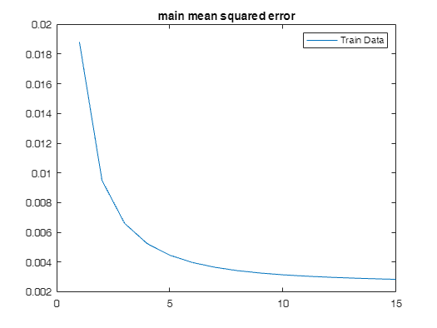

figure();

plot([1:tmp_validation-1],loss_compare,'--');

hold on

plot([1:tmp_validation-1],loss_validation,'.-');

title("validation mean squared error")

legend(["main loss(on validation epochs)","validation loss"])

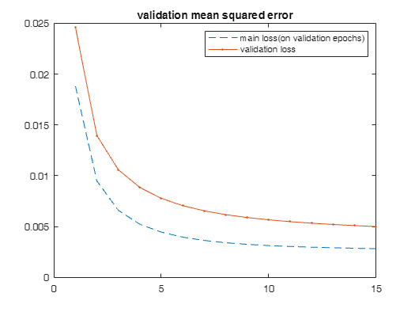

figure;

plot(0:size(d_k,1)-1,d_k);

hold on

plot(0:size(d_k,1)-1,y_pred,"--");

title("Algorithm Performance on train data");

legend(["actual data","predicted"])

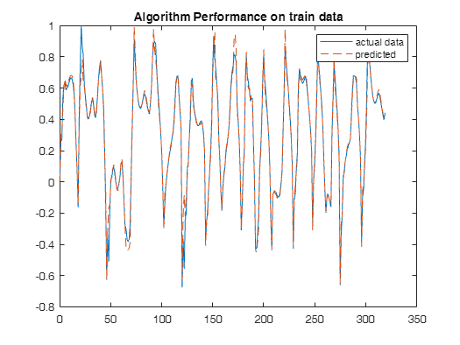

figure;

plot(0:size(x_test,1)-1,y_test(:,1));

hold on

plot(0:size(x_test,1)-1,y_test_pred,"--");

title("Algorithm Performance on test data");

legend(["actual data","predicted"]);

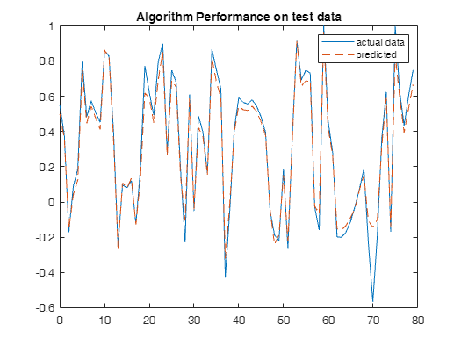

function [output, Phi] = rbf_HL(X, centers, sigma)

num_data = size(X, 1);

num_centers = size(centers, 1);

Phi = zeros(num_data, num_centers);

for i = 1:num_data

for j = 1:num_centers

Phi(i, j) = exp(-norm(X(i,:) - centers(j,:))^2 / (2*sigma^2));

end

end

output = Phi; % Just return Phi if we don't have target values

end

function [centers] = myKmeans(X, k)

% Randomly initialize the cluster centers

num_samples = size(X, 1);

random_indices = randperm(num_samples, k);

centers = X(random_indices, :);

% Initialize variables

cluster_assignment = zeros(num_samples, 1);

max_iters = 100;

iter = 0;

while iter < max_iters

iter = iter + 1;

% Assign each sample to the nearest center

for i = 1:num_samples

distances = sum((X(i, :) - centers) .^ 2, 2);

[~, min_index] = min(distances);

cluster_assignment(i) = min_index;

end

% Update centers

new_centers = zeros(size(centers));

for j = 1:k

cluster_points = X(cluster_assignment == j, :);

if ~isempty(cluster_points)

new_centers(j, :) = mean(cluster_points, 1);

else

% Reinitialize empty cluster

new_centers(j, :) = X(randi(num_samples), :);

end

end

% Check for convergence

if all(new_centers == centers)

break;

end

centers = new_centers;

end

end